High Level Design (HLD) Deloitte Case Study

Revision Number: 1.0

Last date of revision: 01/06/2021

Puspanjali Priyadarsini

# Document Version Control

|  |  |  |  |
| --- | --- | --- | --- |
| **Date Issued** | **Version** | **Description** | **Author** |
| **09th April 2024** | 1.0 | First Version of Complete HLD | Puspanjali Priyadarsini |
| **09th April 2024** | 2.0 | First Version of Complete HLD | Anirudh Bangari |
|  |  |  |  |
|  |  |  |  |
|  |  |  |  |
|  |  |  |  |
|  |  |  |  |

**Contents**

Document Version Control 2

Abstract 3

1. Introduction 5
   1. Why this High-Level Design Document? 5
   2. Scope 5
2. General Description 6
   1. Product Perspective & Problem Statement 6

It is used as a collective term to refer to a broad range of economic services provided

by the ﬁnance industry, which encompasses a broad range of organizations that

manage economic condition

6

* 1. Tools used 6

1. Design Details 7
   1. Functional Architecture 7
   2. Optimization 8
2. KPIs 9
   1. KPIs (Key Performance Indicators) 9
3. Deployment 9

# Abstract

Understanding a country's financial and economic condition is crucial for investors, policymakers, and financial institutions. This analysis focuses on evaluating various economic indicators such as CPI (Consumer Price Index), exchange rates, and export merchandise to gain insights into a country's economic health.

# Introduction

## Why this High-Level Design Document?

The purpose of this High-Level Design (HLD) Document is to add the necessary detail to the current project description to represent a suitable model for coding. This document is also intended to help detect contradictions prior to coding, and can be used as a reference manual for how the modules interact at a high level.

The HLD will:

* + - Present all of the design aspects and define them in detail
    - Describe the user interface being implemented
    - Describe the hardware and software interfaces
    - Describe the performance requirements
    - Include design features and the architecture of the project
    - List and describe the non-functional attributes like:
      * Security
      * Reliability
      * Maintainability
      * Portability
      * Reusability
      * Application compatibility
      * Resource utilization
      * Serviceability

## Scope

The HLD documentation presents the structure of the system, such as the database architecture, application architecture (layers), application flow (Navigation), and technology architecture. The HLD uses non-technical to mildly-technical terms which should be understandable to the administrators of the system.

# General Description

## Product Perspective & Problem Statement

It is used as a collective term to refer to a broad range of economic services provided

by the ﬁnance industry, which encompasses a broad range of organizations that

manage money, including credit unions, banks, credit card companies, insurance

companies, consumer ﬁnance companies, stock brokerages, investment funds A

banking domain is comprised of all the components needed to run a ﬁnancial service

end-to-end. It covers the transaction and distribution process; the ways in which

customers interact with the system, products, and services the organization oﬀers; and

the technology involved

## Tools used

Business Intelligence tools and libraries works such as Numpy, Pandas, Excel, R, Tableau, Power BI are used to build the whole framework.

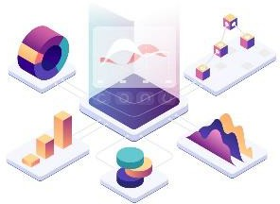



# Design Details

## Functional Architecture

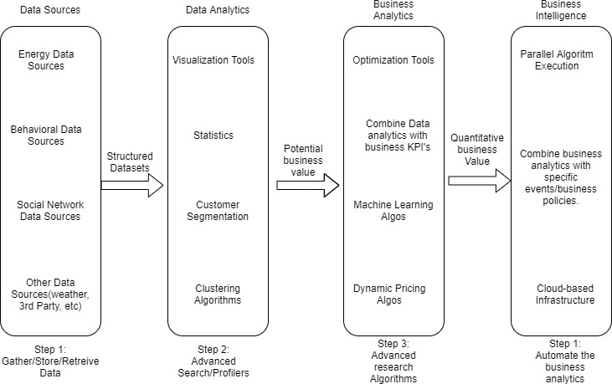

Figure 1: Functional Architecture of Business Intelligence

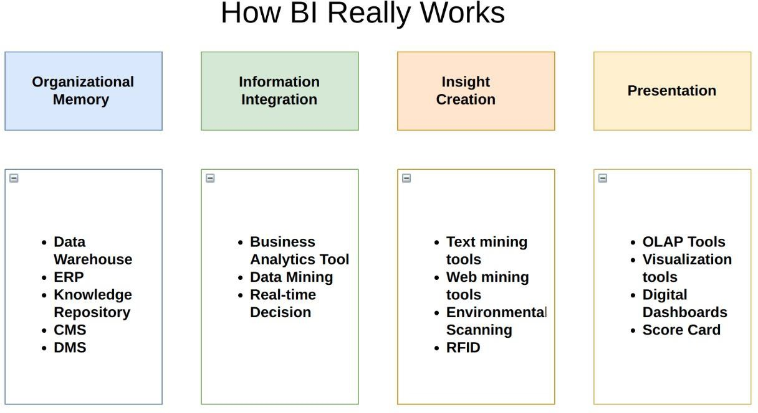

## Optimization

### Your data strategy drives performance

* + - Minimize the number of fields
    - Minimize the number of records
    - Optimize extracts to speed up future queries by materializing calculations, removing columns and the use of accelerated views

### Reduce the marks (data points) in your view

* + - Practice guided analytics. There’s no need to fit everything you plan to show in a single view. Compile related views and connect them with action filters to travel from overview to highly-granular views at the speed of thought.
    - Remove unneeded dimensions from the detail shelf.
    - Explore. Try displaying your data in different types of views.

### Limit your filters by number and type

* + - Reduce the number of filters in use. Excessive filters on a view will create a more complex query, which takes longer to return results. Double-check your filters and remove any that aren’t necessary.
    - Use an include filter. Exclude filters load the entire domain of a dimension, while include filters do not. An include filter runs much faster than an exclude filter, especially for dimensions with many members.
    - [Use a continuous date filter](http://onlinehelp.tableau.com/current/pro/online/mac/en-us/help.htm#filtering_add_dragfields_dates.html). Continuous date filters (relative and range-of-date filters) can take advantage of the indexing properties in your database and are faster than discrete date filters.
    - [Use Boolean or numeric filters](http://www.tableau.com/learn/tutorials/on-demand/logical-calculations). Computers process integers and Booleans (t/f) much faster than strings.
    - Use [parameters](http://onlinehelp.tableau.com/current/pro/online/en-us/help.htm#parameters.html) and [action filters](http://onlinehelp.tableau.com/current/pro/online/en-us/help.htm#actions.html). These reduce the query load (and work across data sources).

### Optimize and materialize your calculations

* + - Perform calculations in the database
    - Reduce the number of nested calculations.
    - Reduce the granularity of LOD or table calculations in the view. The more granular the calculation, the longer it takes.
      * LODs - Look at the number of unique dimension members in the calculation.
      * Table Calculations - the more marks in the view, the longer it will take to calculate.
    - [Where possible, use MIN or MAX instead of AVG](http://onlinehelp.tableau.com/current/pro/online/windows/en-us/help.htm#calculations_aggregation.html). AVG requires more processing than MIN or MAX. Often rows will be duplicated and display the same result with MIN, MAX, or AVG.
    - [Make groups with calculations](http://kb.tableau.com/articles/knowledgebase/creating-groups-using-calculated-fields). Like include filters, calculated groups load only named members of the domain, whereas Tableau’s group function loads the entire domain.
    - [Use Booleans or numeric calculations instead of string calculations](http://onlinehelp.tableau.com/current/pro/online/mac/en-us/help.htm#functions_functions_string.html). Computers can process integers and Booleans (t/f) much faster than strings. Boolean>Int>Float>Date>DateTime>String

# KPIs

Dashboards will be implemented to display and indicate certain KPIs and relevant indicators for the disease.



As and when, the system starts to capture the historical/periodic data for a user, the dashboards will be included to display charts over time with progress on various indicators or factors

## KPIs (Key Performance Indicators)

Key indicators displaying a summary of the Country Economic Conditon and its relationship with different metrics

1. Impact of Cpi on country development
2. Impact of Exchange rate on country economic conditon
3. Influence of Export merchandise on country economic condition

# Deployment

Prioritizing data and analytics couldn’t come at a better time. Your company, no matter what size, is already collecting data and most likely analyzing just a portion of it to solve business problems, gain competitive advantages, and drive enterprise transformation. With the explosive growth of enterprise data, database technologies, and the high demand for analytical skills, today’s most effective IT organizations have shifted their focus to enabling self-service by deploying and operating Tableau at scale, as well as organizing, orchestrating, and unifying disparate sources of data for business users and experts alike to author and consume content.

Power BI offers flexibility and scalability to fit seamlessly into your existing enterprise architecture. Whether you prefer an on-premises, cloud-based, or hybrid solution, Power BI provides options tailored to your organization's needs. Below is a comparison of the three types of Power BI deployment options:

### Power BI Deployment Options

| **TYPE** | **PROS** | **CONS** |
| --- | --- | --- |
| Power BI Report Server - On Premises | • Full control of hardware and software | • Requires dedicated administrators for management |
|  | • Infrastructure and data remain behind firewall | • Additional infrastructure for off-network access |
|  | • Integration with existing Microsoft services |  |
| Power BI - Public Cloud | • Fully managed service | • Subscription-based pricing |
|  | • Scalable and flexible | • Data stored in Microsoft cloud |
|  | • No need for hardware maintenance |  |
| Power BI Embedded | • Embed reports and dashboards in apps | • Cost based on usage |
|  | • Customizable for specific needs | • Requires development effort |

### Deployment Considerations

Depending on your organizational roles and responsibilities, the deployment of Power BI should be planned carefully:

* **On-Premises**: Installed by systems administrators and the designated Power BI Administrator, coordinating with IT roles for hardware and software management.
* **Public Cloud**: Integrated with existing cloud services and configured to meet your organization's needs. It offers scalability and flexibility with subscription-based pricing.
* **Embedded**: Designed for developers to embed Power BI reports and dashboards into custom applications. It requires development effort but offers customization options tailored to specific needs.

### Planning Your Deployment

The Data & Analytics Survey, completed by business teams, should identify and prioritize data use cases, audience size, and users. This information will guide your deployment strategy, including sizing, installation, and configuration of Power BI.

Administrators will also need to plan for the client software installation of Power BI Desktop, Power BI Mobile, and other relevant tools to ensure a smooth deployment process.

### Conclusion

Power BI offers a range of deployment options to suit your organization's needs, whether you prefer an on-premises solution for full control or a cloud-based service for scalability and flexibility. By understanding your requirements and planning accordingly, you can leverage Power BI's capabilities to drive data-driven insights across your organization.

.